BOWLING FEDERATION OF FEDERATION OF INDIA

ELECTION OF THE BOWLING FEDERATION OF INDIA (2022-2026)

FORM 1

ELECTORAL COLLEGE
S No. | Name of the Permanent Member (State/ Union Territory Association) | Name of the authorized representative | Signature  (On the day of the Poll)
1 | Rajasthan Bowling Association | Kamal Sharma
 | Rajasthan Bowling Association | Shanti Swaroop Maharwal
2 | Punjab Bowling Federation of India | Sunaina Kumari
 | Punjab Bowling Federation of India | Gurmehar Sekhon
3 | Himachal Pradesh Bowling Association | Shivendra Pal Kuthlair
 | Himachal Pradesh Bowling Association | Lokinder Singh
4 | Chandigarh Bowling Association | Anumit Singh Sodhi
 | Chandigarh Bowling Association | Ashwini Kumar
5 | Kerala Bowling Association | S Sumannath Pai
 | Kerala Bowling Association | S Gopinath Pai
6 | UP Bowling Association | K B S Rathi
 | UP Bowling Association | Usman Ghani Khan
7 | MP Bowling Association | Dr Vinod Pradhan
 | MP Bowling Association | S K Khurana
8 | UK Bowling Association | Kaushal Kumar
 | UK Bowling Association | Trishla Singh
9 | Jharkhand Bowling Association | Madhukant Pathak
 | Jharkhand Bowling Association | Ashish Kumar
10 | Gujrat Bowling Association | Paramrajsinhji Rana
 | Gujrat Bowling Association | Mayurdhwajsinji Parmar
11 | Arunachal Pradesh Bowling Association | Oniya Padi
11 | Arunachal Pradesh Bowling Association | Marngam Kamki
12 | Assam Bowling Association | Durgadas Boro
 | Assam Bowling Association | Naba Basumatary
13 | WB Bowling Association | Ravi Bhagnani
 | WB Bowling Association | Devesh Srivastva
14 | Manipur Bowling Association | Angom Johnson Singh
 | Manipur Bowling Association | Kongkham Hemandro  Singh
15 | Delhi Bowling Association | Dr D R Saini
 | Delhi Bowling Association | Anju Luthra
16 | Bihar Bowling Association | Prasenjit Mehta
 | Bihar Bowling Association | Asgar Hussain
17 | Odisha Bowling Association | Kailash Majhi
 | Odisha Bowling Association | Sumit Ranjan Purohit
18 | Maharashtra Bowling Association | Abhay Ahuja
 | Maharashtra Bowling Association | Purav Raja
19 | Andhra Pradesh Bowling Association | -
 | Andhra Pradesh Bowling Association | -
20 | Chhattisgarh Bowling Association | Ravindranath Mishra
 | Chhattisgarh Bowling Association | Rahul Sahu
21 | Karnataka Bowling Association | -
 | Karnataka Bowling Association | -
22 | Tamilnadu Bowling Association | -
 | Tamilnadu Bowling Association | -
23 | Meghalaya Bowling Association | A. Khongwir
 | Meghalaya Bowling Association | Ms K Khyriem,

Date: 29th Sep 2022 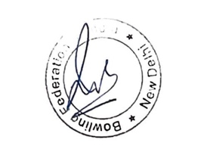 Signature:
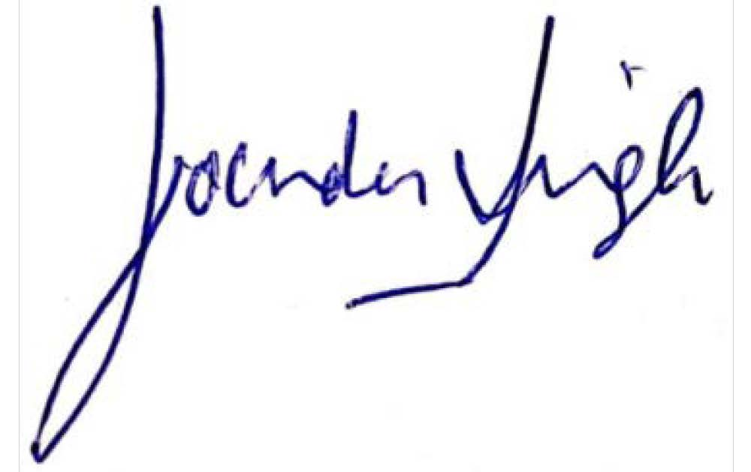
Place: Chandigarh

